**ABU BAKAR SIDDIK**

**ID: 19897, Course: BAN 223- Relational Databases**

**Instructor: Dr. Vidhyacharan Bhaskar**

**Presentation Queries**

**#Basic Queries: -**

**1. Retrieve the player with the maximum goals scored/Who scored the most goals in a single match?**  
  
SELECT PlayerID, MAX(GoalsScored) AS MostGoals

FROM PlayerPerformance GROUP BY PlayerID

ORDER BY MostGoals DESC LIMIT 1;

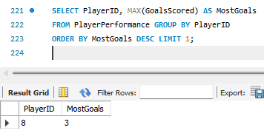

**2. (Having Clause)Retrieve teams with an average player age under 28 or Which teams have an average player age of less than 28?**

SELECT TeamID, round(AVG(Age)) AS AverageAge

FROM Players

GROUP BY TeamID

HAVING AverageAge < 28;

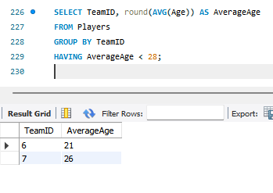

**3. (Like Clause)Find all matches played in a 'Stadium’ like location Where the location name is like Stadium.  
  
SELECT MatchID, Date, Location   
FROM Matches**

**WHERE Location LIKE '%Stadium%';**

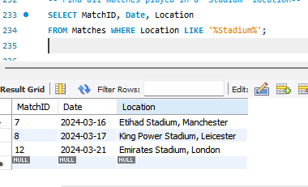

**4. Count the number of players in each team with age greater than 25.**

SELECT TeamID, COUNT(*) AS PlayersOver25

FROM Players

WHERE Age > 25

GROUP BY TeamID;

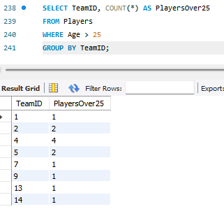

**5. Update a Team's League**  
UPDATE Teams

SET League = 'La Liga 2’

WHERE TeamID = 15;

select* from teams;

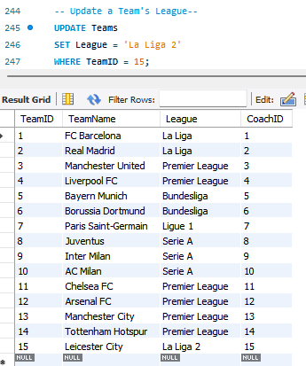

**6. Inserting a new record to the Coaches table.**

INSERT INTO Coaches (CoachID, Name, Nationality, DateStarted) VALUES

(16, 'Elena Moreno', 'Mexican', '2021-01-10’);

select * from coaches;

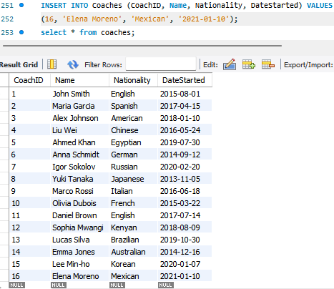

**# SQL Queries (Intermediate): -**

**1. (Inner Join Based) List all players with their team names and match details where they scored at least one goal.**

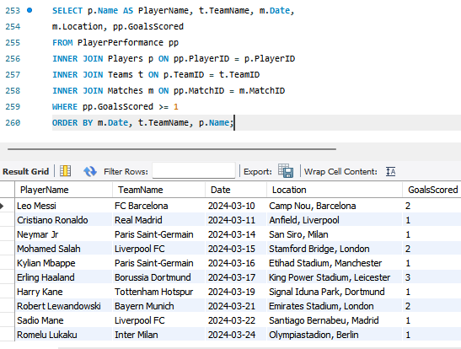

**2. (Left Join Based) List all teams and the count of matches played.**

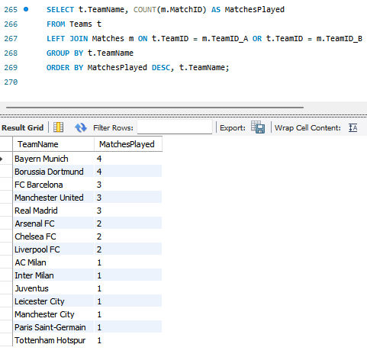

**# SQL Queries (Advanced)  
Joins and Nested Query including Aggregations: -**

**1.Find all players who have an average number of goals scored per match that is above the overall average goals scored per match by all players. Additionally, list each qualifying player's name, team name, and their average goals per match.**

